SF.SmokeTestScripts_TC_SF_ManagerCreateGreenspaceLead_Instance1_12-Apr-2017_02-44-11_PM_Invoke_Application.png



SF.SmokeTestScripts_TC_SF_ManagerCreateGreenspaceLead_Instance1_12-Apr-2017_02-44-21_PM_Login.png

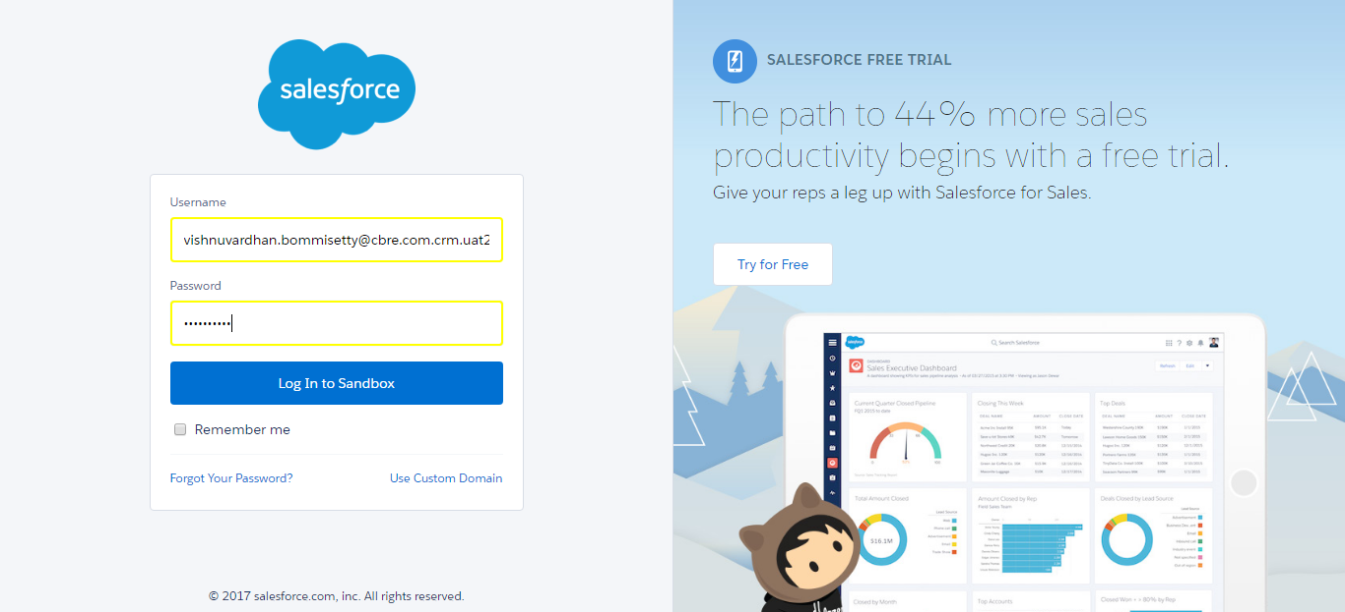

SF.SmokeTestScripts_TC_SF_ManagerCreateGreenspaceLead_Instance1_12-Apr-2017_02-44-33_PM_Verify_Login.png

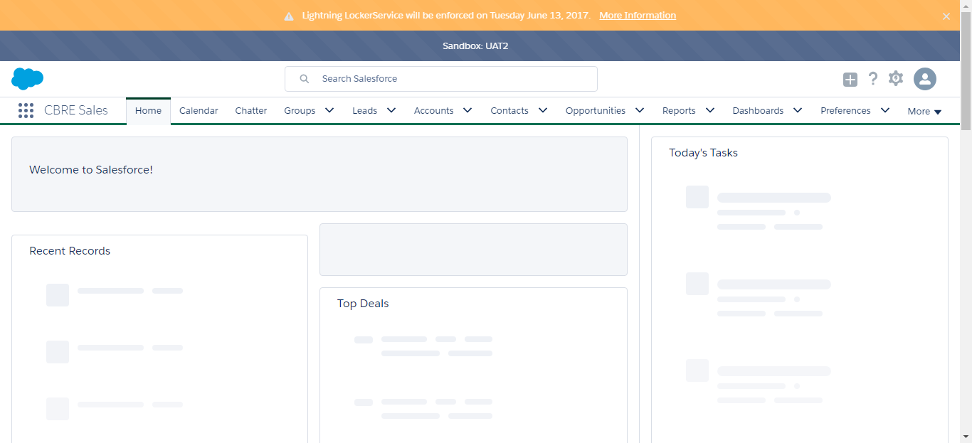

SF.SmokeTestScripts_TC_SF_ManagerCreateGreenspaceLead_Instance1_12-Apr-2017_02-45-14_PM_Verify_Lead_Status_Field.png

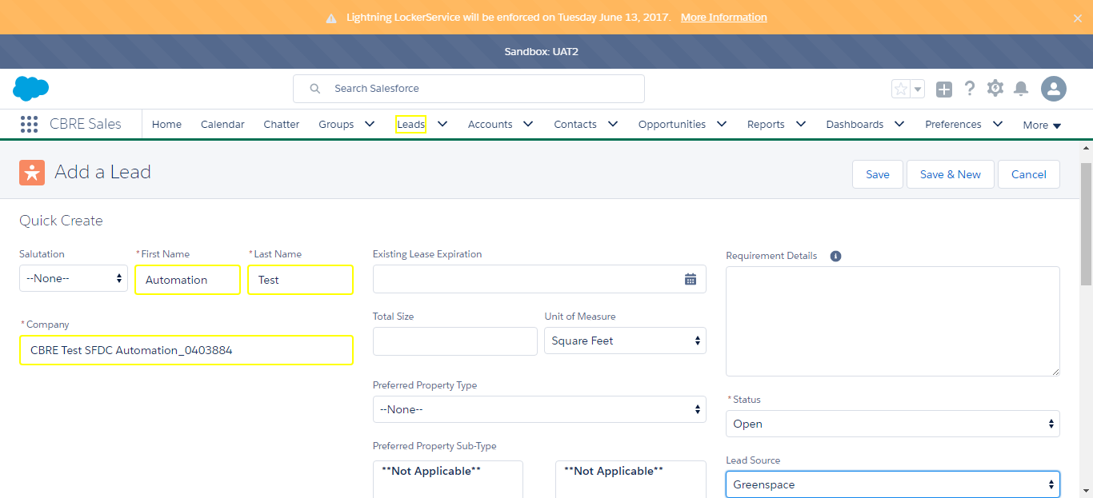

SF.SmokeTestScripts_TC_SF_ManagerCreateGreenspaceLead_Instance1_12-Apr-2017_02-45-38_PM_Create_Greenspace_Lead.png

